Nama : Tika Pratiwi

NIM : L200170046

Kelas : C

LATIHAN

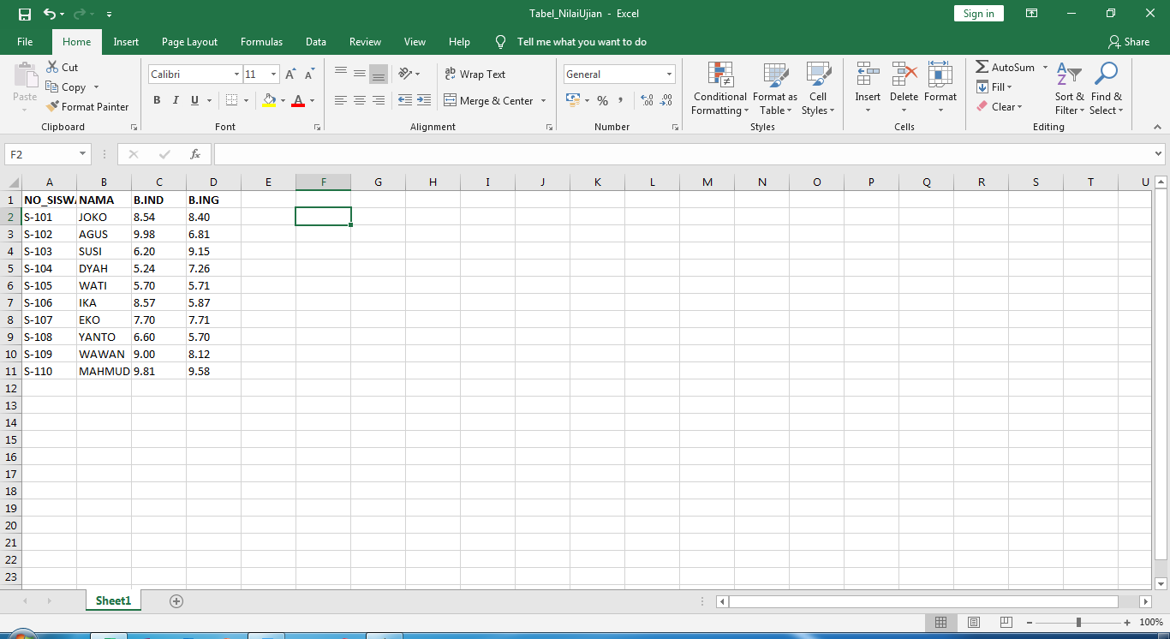

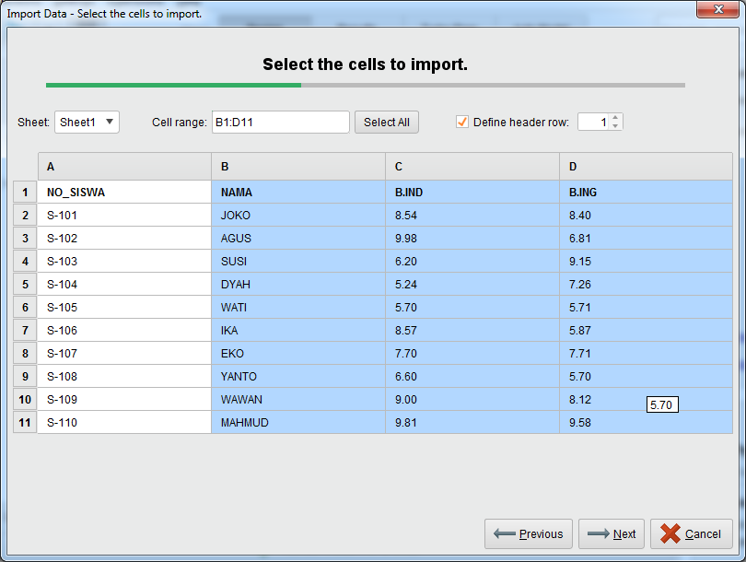

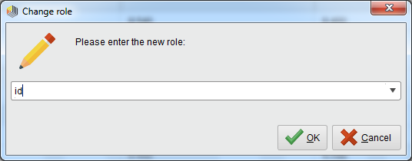

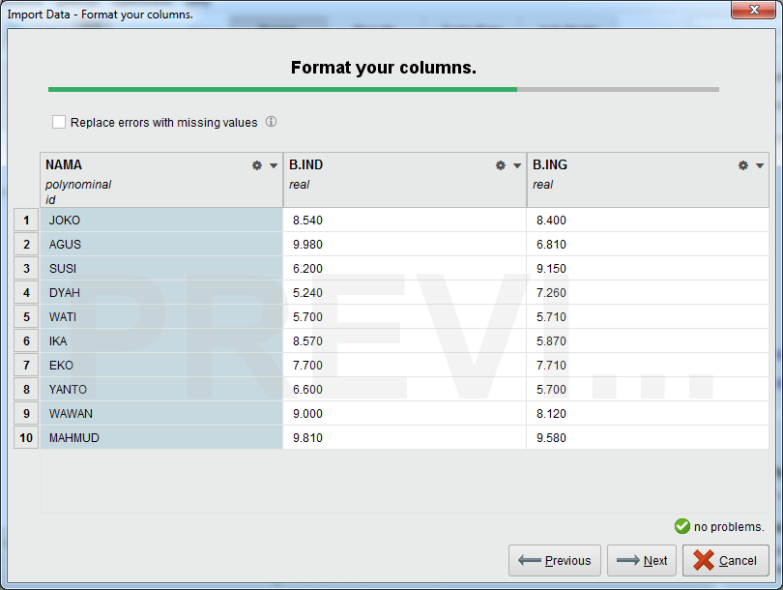

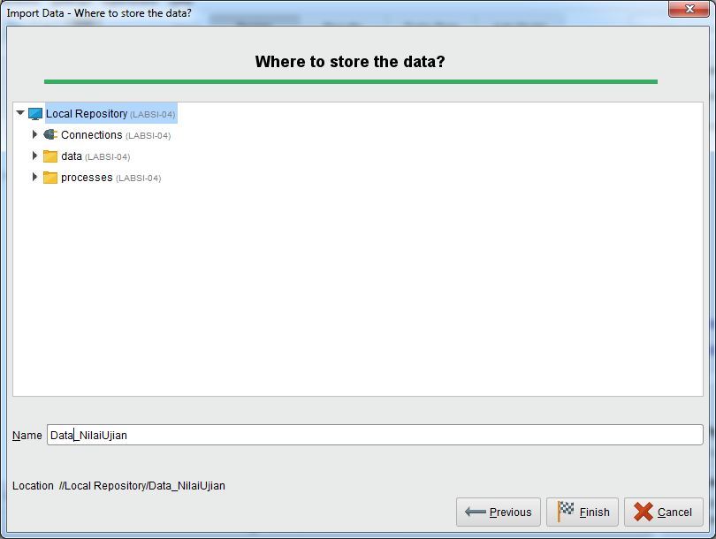

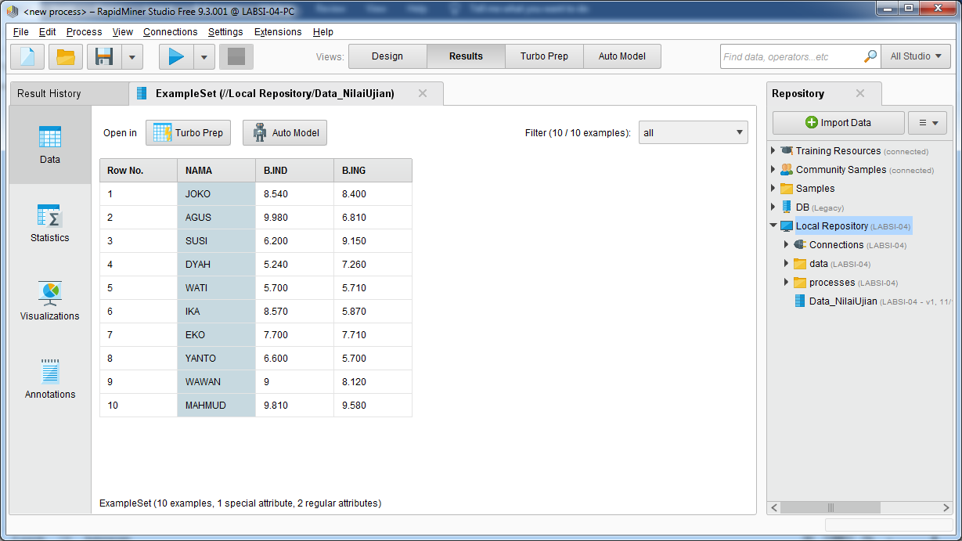

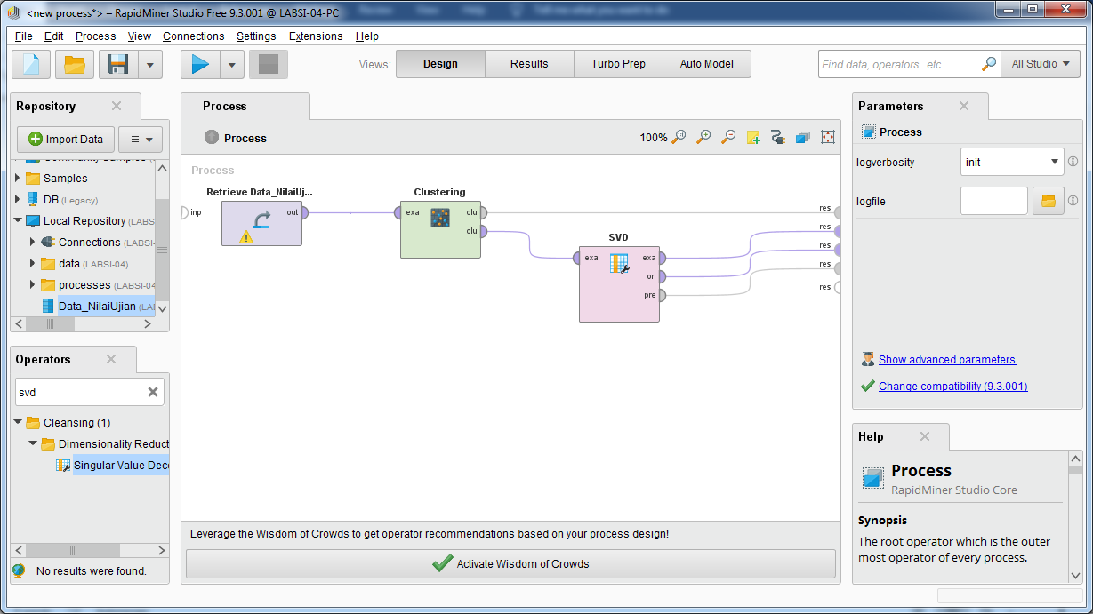

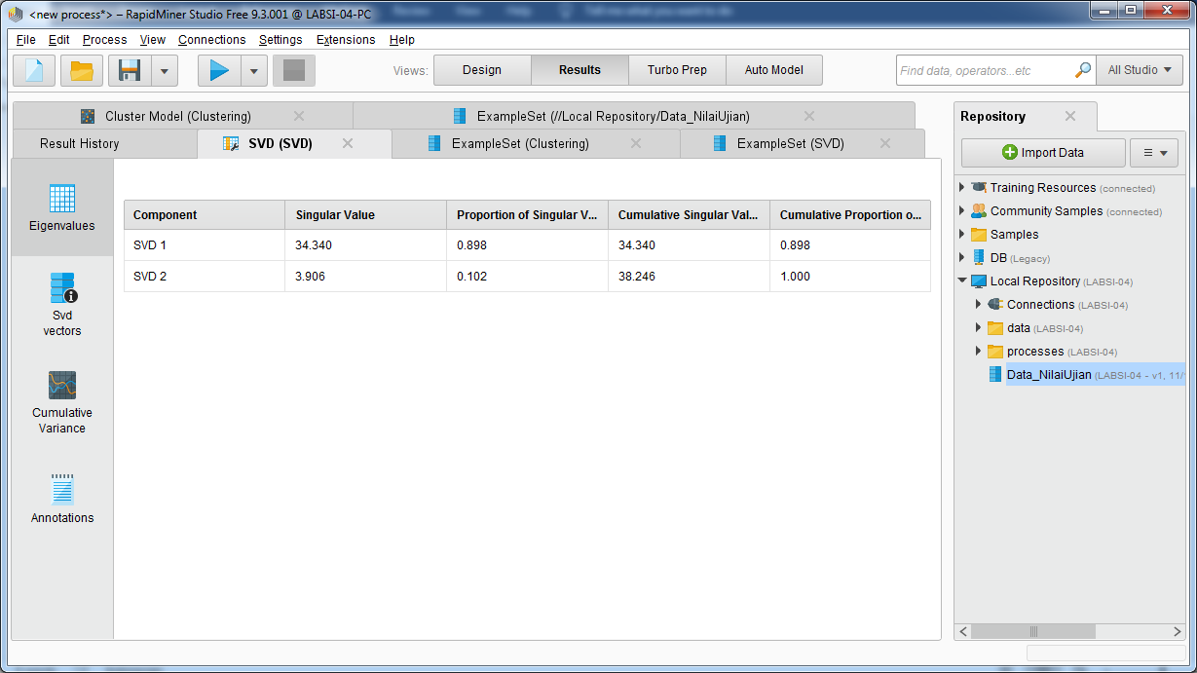

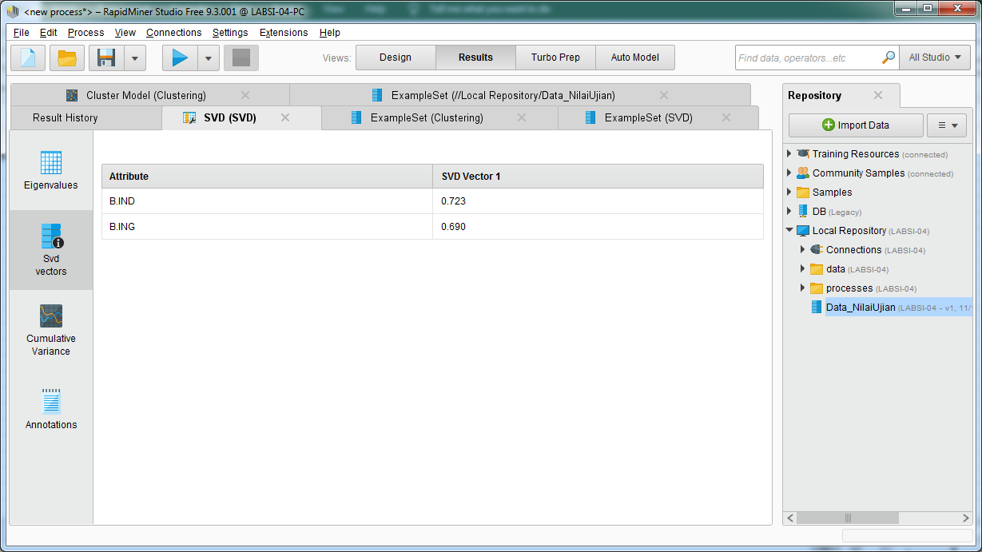

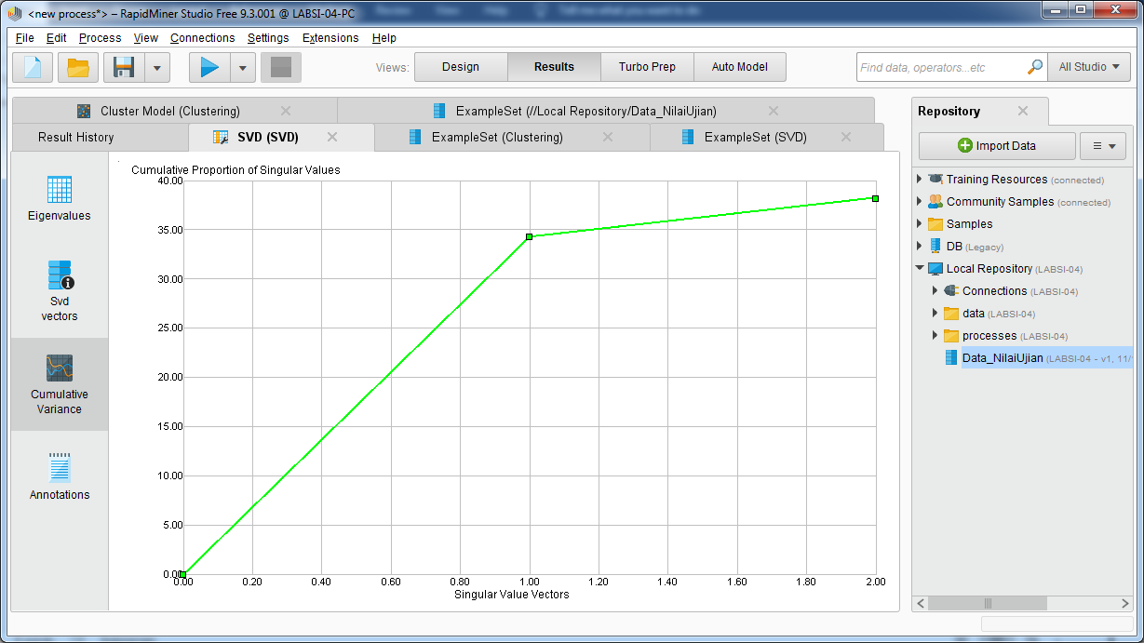

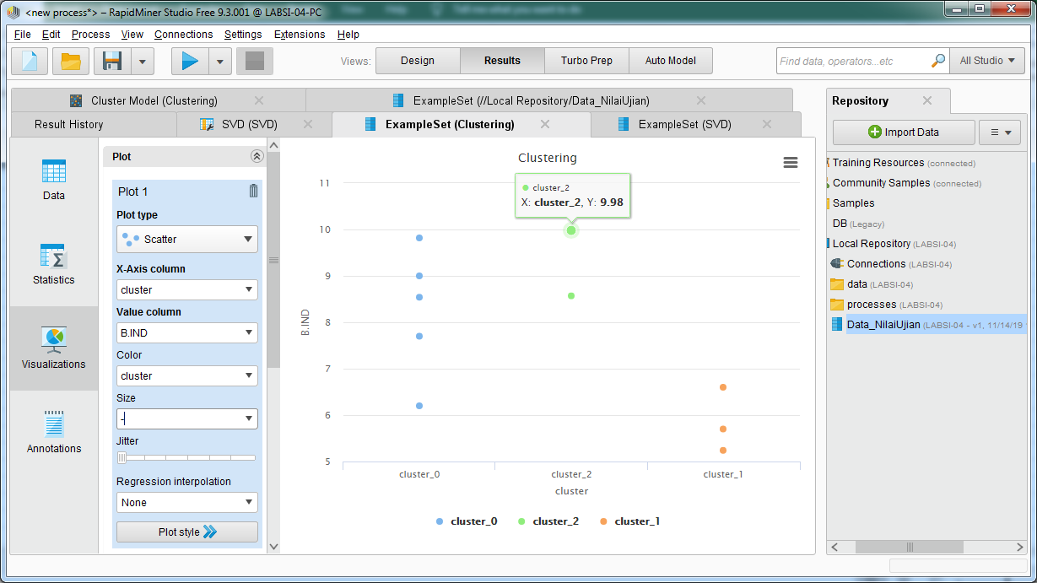

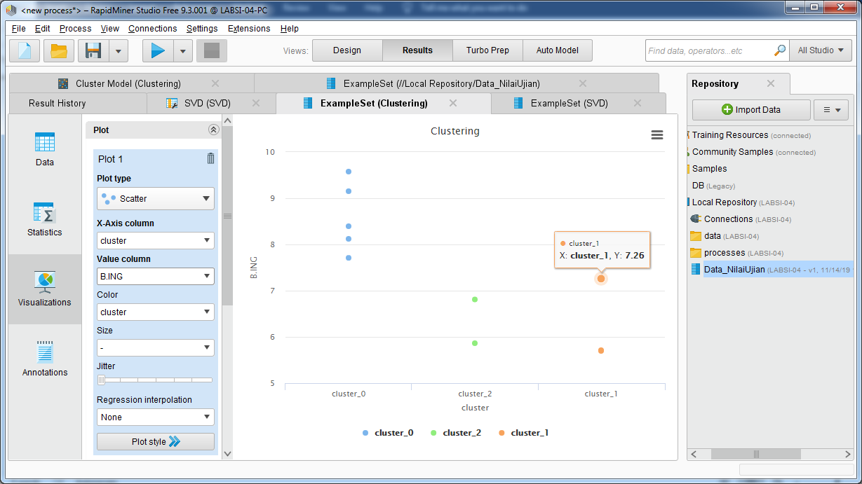

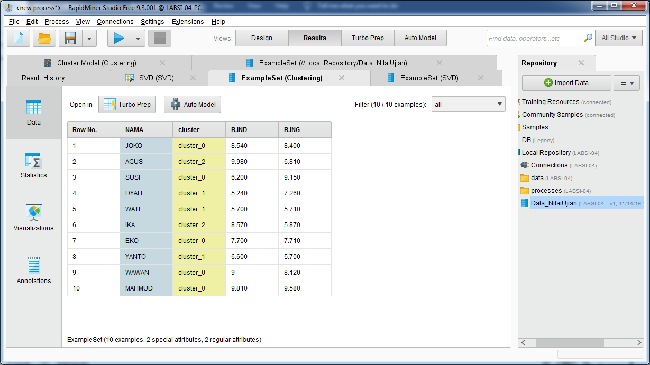

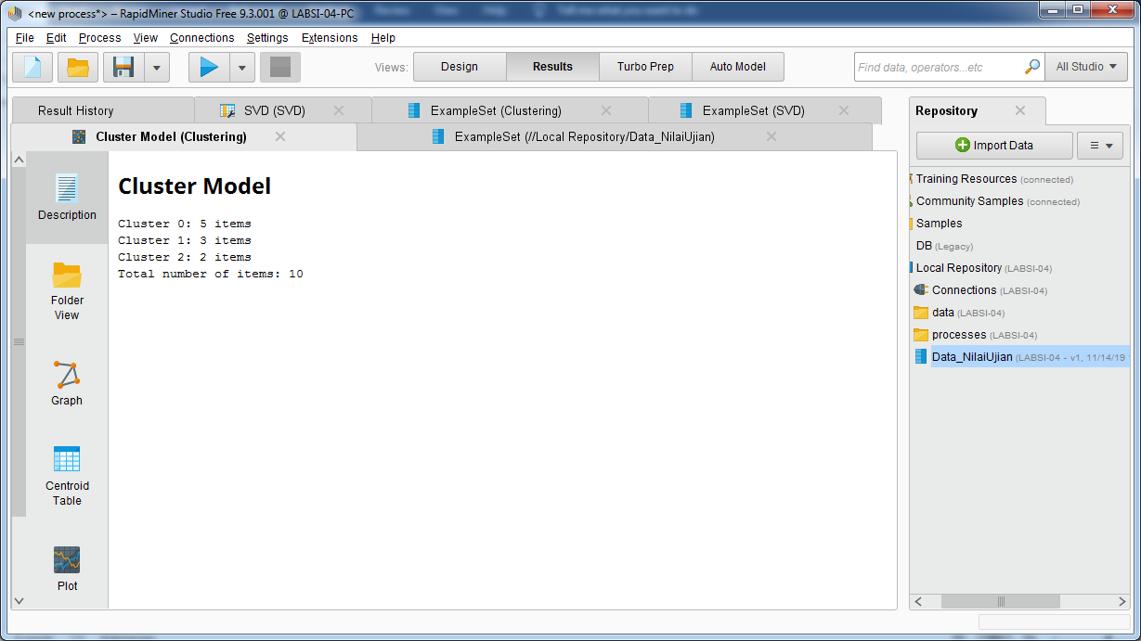

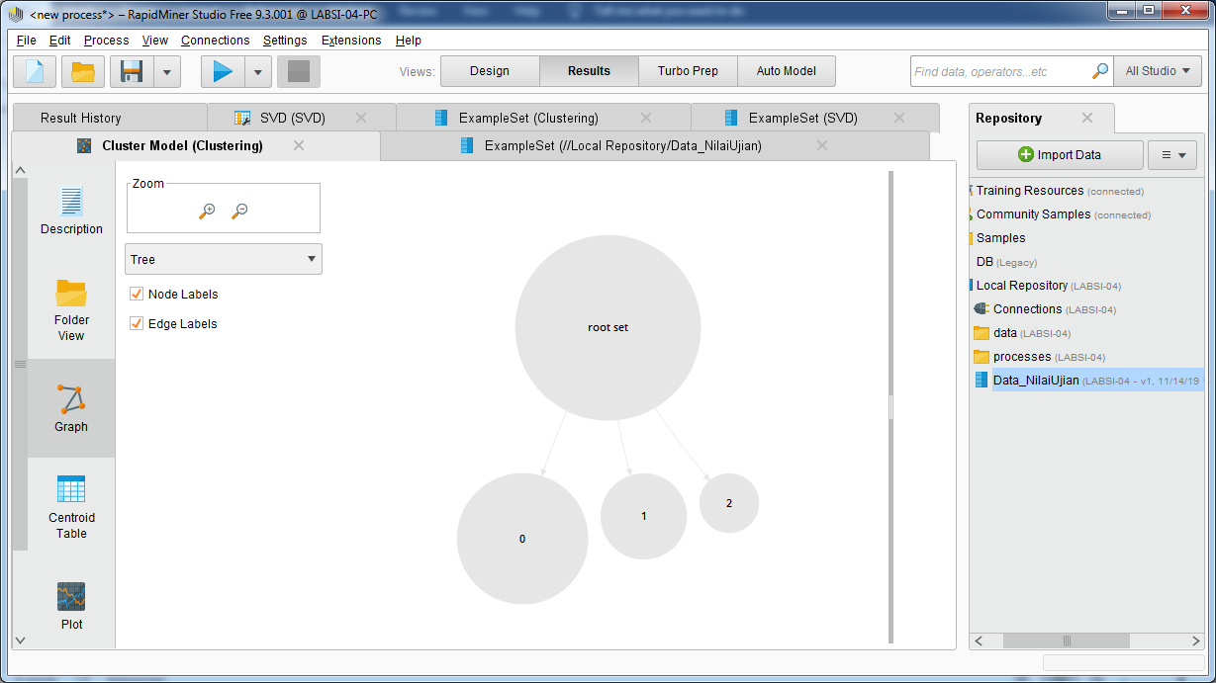

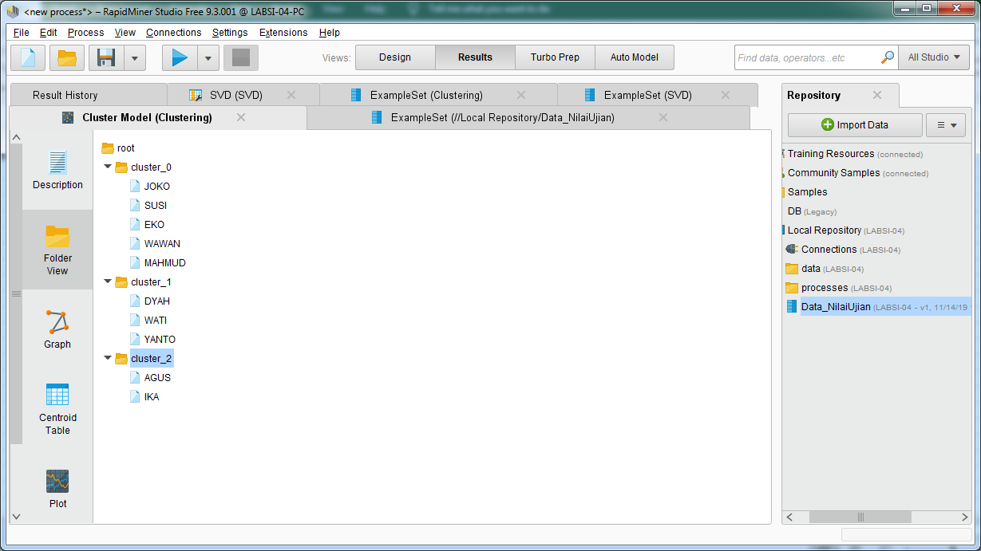

|  |  |  |  |  |
| --- | --- | --- | --- | --- |
| **CLUSTERING** | **NO_SISWA** | **NAMA** | **B.IND** | **B.ING** |
| 0 | S-101 | JOKO | 8.54 | 8.40 |
| 0 | S-103 | SUSI | 6.20 | 9.15 |
| 0 | S-107 | EKO | 7.70 | 7.71 |
| 0 | S-109 | WAWAN | 9.00 | 8.12 |
| 0 | S-110 | MAHMUD | 9.81 | 9.58 |
| 1 | S-104 | DYAH | 5.24 | 7.26 |
| 1 | S-105 | WATI | 5.70 | 5.71 |
| 1 | S-108 | YANTO | 6.60 | 5.70 |
| 2 | S-102 | AGUS | 9.98 | 6.81 |
| 2 | S-106 | IKA | 8.57 | 5.87 |